Constructing Rectangle

Definition
# Source: AI Source: Provided by: [Data Path: Persons Table -> ID Column: 1, Name_En Column: Motasem Essam] -> From: [ChatGPT] on [7/25/2026]
Constructing a Rectangle is the geometric construction of a quadrilateral with four right angles and opposite sides equal and parallel, using classical geometric tools such as a straightedge and compass.
A rectangle $ABCD$satisfies:
$$\boxed{∠A=∠B=∠C=∠D={90}^{∘}}$$
and:
$$\boxed{AB=CD} \\ \boxed{BC=AD}$$
with:
$$\boxed{AB∥CD} \\ \boxed{BC∥AD}$$

Fundamental Concept
# Source: AI Source: Provided by: [Data Path: Persons Table -> ID Column: 1, Name_En Column: Motasem Essam] -> From: [ChatGPT] on [7/25/2026]
A rectangle can be constructed when sufficient information is given, such as:
- one side and the adjacent side
- two adjacent side lengths
- three vertices
- one side and a diagonal
- a given diagonal and additional information
The most fundamental construction is constructing a rectangle from two adjacent side lengths.
If:
$$AB=a$$
and:
$$AD=b$$
then the rectangle has dimensions:
$$\boxed{a×b}$$

Main Construction: Rectangle from Two Adjacent Sides
# Source: AI Source: Provided by: [Data Path: Persons Table -> ID Column: 1, Name_En Column: Motasem Essam] -> From: [ChatGPT] on [7/25/2026]
Suppose the required adjacent sides are:
$$AB=a, AD=b$$
Steps
- Construct the given segment $\overset{‾}{AB}$.
- Construct a perpendicular line to $AB$through $A$.
- On this perpendicular, mark $D$such that:
$$AD=b$$
- Construct a line through $D$parallel to $AB$.
- Construct a line through $B$parallel to $AD$.
- Let the two parallel lines intersect at $C$.
- Connect the vertices in order:
$$A-B-C-D-A$$
- The resulting quadrilateral $ABCD$is a rectangle.
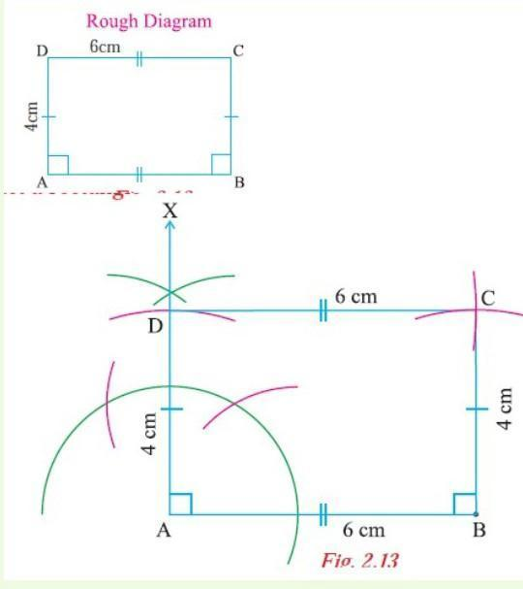
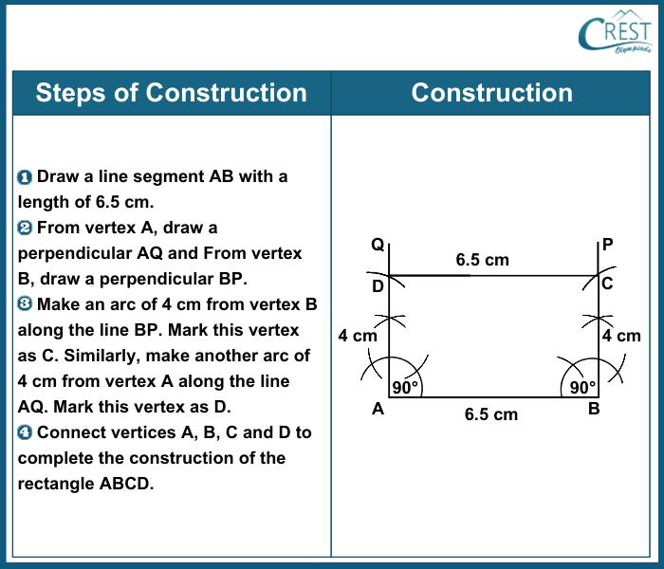
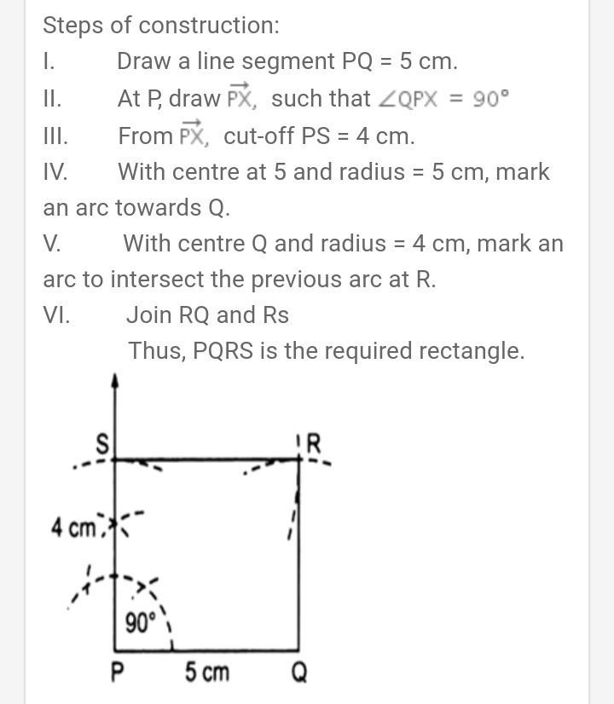
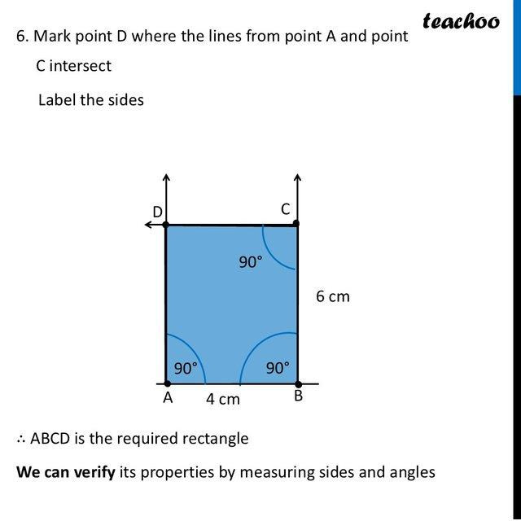
Result
$$\boxed{AB=CD=a} \\ \boxed{AD=BC=b}$$
and:
$$\boxed{∠A=∠B=∠C=∠D={90}^{∘}}$$
Therefore:
$$\boxed{ABCD\text{ is a rectangle}}$$

Why the Construction Works
# Source: AI Source: Provided by: [Data Path: Persons Table -> ID Column: 1, Name_En Column: Motasem Essam] -> From: [ChatGPT] on [7/25/2026]
At $A$, the construction creates:
$$AD⊥AB$$
Therefore:
$$∠DAB={90}^{∘}$$
The line through $D$is constructed parallel to $AB$, while the line through $B$is constructed parallel to $AD$.
Therefore:
$$AB∥CD$$
and:
$$AD∥BC$$
Since $AD⊥AB$, the parallel lines preserve the right-angle relationship, giving:
$$∠A=∠B=∠C=∠D={90}^{∘}$$
Thus the quadrilateral is a rectangle.

Constructing a Rectangle from Three Given Vertices
# Source: AI Source: Provided by: [Data Path: Persons Table -> ID Column: 1, Name_En Column: Motasem Essam] -> From: [ChatGPT] on [7/25/2026]
Suppose three vertices $A$, $B$, and $D$are given, with $A$as the common vertex.
Steps
- Draw or identify $AB$.
- Draw or identify $AD$.
- Verify that:
$$AB⊥AD$$
- Through $B$, construct a line parallel to $AD$.
- Through $D$, construct a line parallel to $AB$.
- Let their intersection be $C$.
- Connect the vertices.
Then:
$$\boxed{ABCD\text{ is a rectangle}}$$
This construction uses the principle:
$$\boxed{\text{Perpendicular + Parallel Lines}→\text{Rectangle}}$$

Constructing a Rectangle from a Given Side and Diagonal
# Source: AI Source: Provided by: [Data Path: Persons Table -> ID Column: 1, Name_En Column: Motasem Essam] -> From: [ChatGPT] on [7/25/2026]
Suppose side $AB$and diagonal $AC$are given.
Steps
- Construct the given side $AB$.
- At $B$, construct a perpendicular to $AB$.
- Set the compass to the given diagonal length $AC$.
- With center $A$, draw an arc that intersects the perpendicular through $B$at $C$.
- Through $C$, construct a line parallel to $AB$.
- Through $A$, construct a line parallel to $BC$.
- Their intersection gives $D$.
- Connect the vertices.
The right triangle $ABC$gives:
$$AC^{2}=AB^{2}+BC^{2}$$
so if:
$$AB=a, AC=d$$
then:
$$\boxed{BC=\sqrt{d^{2}-a^{2}}}$$
A valid non-degenerate rectangle requires:
$$\boxed{d>a}$$

Constructing a Rectangle from Its Dimensions
# Source: AI Source: Provided by: [Data Path: Persons Table -> ID Column: 1, Name_En Column: Motasem Essam] -> From: [ChatGPT] on [7/25/2026]
If the dimensions are given as:
$$L=\text{length}$$
and:
$$W=\text{width}$$
construct:
$$AB=L$$
and:
$$AD=W$$
Then use perpendicular and parallel constructions to locate $B,C,D$.
The resulting rectangle has:
$$\boxed{\text{Length}=L} \\ \boxed{\text{Width}=W}$$
Its perimeter is:
$$\boxed{P=2\left(L+W\right)}$$
Its area is:
$$\boxed{A=LW}$$
Its diagonal is:
$$\boxed{d=\sqrt{L^{2}+W^{2}}}$$

Properties of a Constructed Rectangle
# Source: AI Source: Provided by: [Data Path: Persons Table -> ID Column: 1, Name_En Column: Motasem Essam] -> From: [ChatGPT] on [7/25/2026]
For rectangle $ABCD$:
Four Right Angles
$$\boxed{∠A=∠B=∠C=∠D={90}^{∘}}$$
Opposite Sides
$$\boxed{AB=CD} \\ \boxed{BC=AD}$$
Parallel Sides
$$\boxed{AB∥CD} \\ \boxed{AD∥BC}$$
Diagonals
The diagonals are equal:
$$\boxed{AC=BD}$$
They also bisect each other.
If they intersect at $O$:
$$\boxed{AO=OC}$$
and:
$$\boxed{BO=OD}$$
However, unlike a square, the diagonals of a general rectangle are not perpendicular.

Types of Rectangle Construction
# Source: AI Source: Provided by: [Data Path: Persons Table -> ID Column: 1, Name_En Column: Motasem Essam] -> From: [ChatGPT] on [7/25/2026]
These are primarily construction situations, rather than different mathematical types of rectangles.
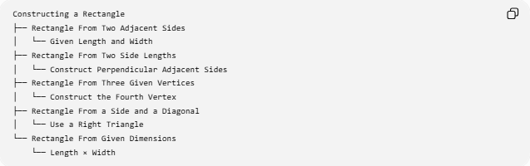
Constructing a Rectangle
├── Rectangle From Two Adjacent Sides
│ └── Given Length and Width
├── Rectangle From Two Side Lengths
│ └── Construct Perpendicular Adjacent Sides
├── Rectangle From Three Given Vertices
│ └── Construct the Fourth Vertex
├── Rectangle From a Side and a Diagonal
│ └── Use a Right Triangle
└── Rectangle From Given Dimensions
└── Length × Width

Construction Classification
# Source: AI Source: Provided by: [Data Path: Persons Table -> ID Column: 1, Name_En Column: Motasem Essam] -> From: [ChatGPT] on [7/25/2026]
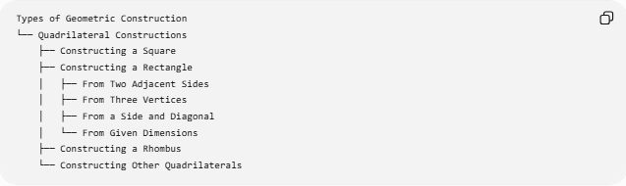
Types of Geometric Construction
└── Quadrilateral Constructions
├── Constructing a Square
├── Constructing a Rectangle
│ ├── From Two Adjacent Sides
│ ├── From Three Vertices
│ ├── From a Side and Diagonal
│ └── From Given Dimensions
├── Constructing a Rhombus
└── Constructing Other Quadrilaterals
A more detailed classification is:
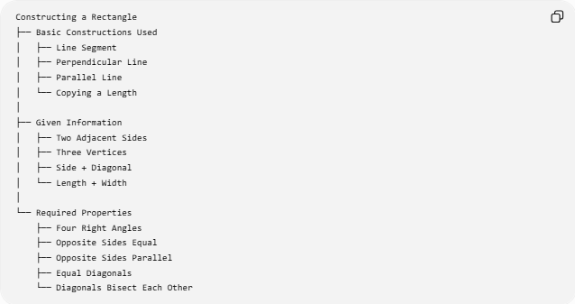
Constructing a Rectangle
├── Basic Constructions Used
│ ├── Line Segment
│ ├── Perpendicular Line
│ ├── Parallel Line
│ └── Copying a Length
│
├── Given Information
│ ├── Two Adjacent Sides
│ ├── Three Vertices
│ ├── Side + Diagonal
│ └── Length + Width
│
└── Required Properties
├── Four Right Angles
├── Opposite Sides Equal
├── Opposite Sides Parallel
├── Equal Diagonals
└── Diagonals Bisect Each Other

Rectangle and Square Construction
# Source: AI Source: Provided by: [Data Path: Persons Table -> ID Column: 1, Name_En Column: Motasem Essam] -> From: [ChatGPT] on [7/25/2026]
A square is a special type of rectangle.
If a rectangle has:
$$AB=BC$$
then all four sides become equal, so the rectangle is a square.
Therefore:
$$\boxed{\text{Square}⊂\text{Rectangle}}$$
in the classification of quadrilaterals.
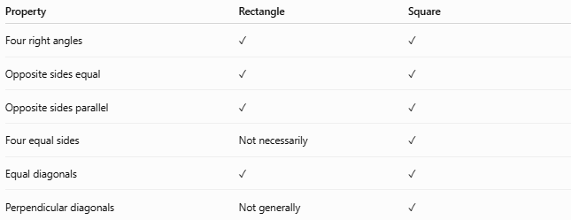
Property | Rectangle | Square
Four right angles | ✓ | ✓
Opposite sides equal | ✓ | ✓
Opposite sides parallel | ✓ | ✓
Four equal sides | Not necessarily | ✓
Equal diagonals | ✓ | ✓
Perpendicular diagonals | Not generally | ✓

Example
# Source: AI Source: Provided by: [Data Path: Persons Table -> ID Column: 1, Name_En Column: Motasem Essam] -> From: [ChatGPT] on [7/25/2026]
Construct a rectangle with:
$$L=8\text{ cm}$$
and:
$$W=5\text{ cm}$$
Construct:
$$AB=8\text{ cm}$$
Then construct:
$$AD=5\text{ cm}$$
perpendicular to $AB$.
Complete the rectangle using parallel lines.
The resulting rectangle has:
$$\boxed{AB=CD=8\text{ cm}} \\ \boxed{AD=BC=5\text{ cm}}$$
Perimeter:
$$P=2\left(8+5\right)=26\text{ cm}$$
Area:
$$A=8\left(5\right)=40{\text{ cm}}^{2}$$
Diagonal:
$$d=\sqrt{8^{2}+5^{2}} \\ \boxed{d=\sqrt{89}\text{ cm}}$$

Tools Used
# Source: AI Source: Provided by: [Data Path: Persons Table -> ID Column: 1, Name_En Column: Motasem Essam] -> From: [ChatGPT] on [7/25/2026]
Straightedge
Used to:
- draw lines
- connect vertices
- construct parallel lines
- extend lines
Compass
Used to:
- transfer lengths
- construct perpendiculars
- construct equal distances
- locate points
Therefore:
$$\boxed{\text{Classical Rectangle Construction}=\text{Straightedge + Compass}}$$

Key Points
# Source: AI Source: Provided by: [Data Path: Persons Table -> ID Column: 1, Name_En Column: Motasem Essam] -> From: [ChatGPT] on [7/25/2026]
- A rectangle has four right angles.
- Opposite sides are equal.
- Opposite sides are parallel.
- Adjacent sides are perpendicular.
- The diagonals are equal.
- The diagonals bisect each other.
- The diagonals are not generally perpendicular.
- A rectangle can be constructed from two adjacent side lengths.
- A rectangle can also be constructed from three vertices or from a side and diagonal.
- The perimeter is:
$$P=2\left(L+W\right)$$
- The area is:
$$A=LW$$
- The diagonal is:
$$d=\sqrt{L^{2}+W^{2}}$$
- A square is a special rectangle in which:
$$L=W$$

Conclusion
# Source: AI Source: Provided by: [Data Path: Persons Table -> ID Column: 1, Name_En Column: Motasem Essam] -> From: [ChatGPT] on [7/25/2026]
Constructing a Rectangle is the geometric construction of a quadrilateral with four right angles and two pairs of equal, parallel opposite sides. The fundamental construction uses a given side, a perpendicular line to establish the adjacent side, and parallel lines to complete the fourth vertex. Rectangle construction therefore combines several basic geometric constructions, especially line segments, perpendicular lines, parallel lines, and copying lengths.

